Toward a DNA Solution to the Shortest Common Superstring Problem
Greg Gloor, Lila Kari, Michelle Gaasenbeek, and Sheng Yu
International Journal on Artificial Intelligence Tools, Vol. 8, No. 4 ,
pp. 385-399, 1999
Abstract
This paper proposes a DNA algorithm for solving an NP-complete problem—The Shortest Common Superstring Problem by manipulation of biomolecules.
- The Shortest Common Superstring Problem
- Input: Alphabet , finite set =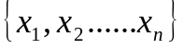, 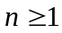, of strings from 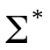, and a positive integer .
- Question: Is there a string with length 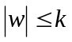such that each string 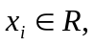 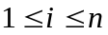 , is a substring of.
- Example:
If 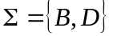, 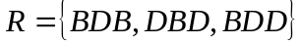 and =5, the answer to the problem is “yes”. Indeed, the superstring 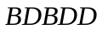of length 5, contains all the input strings as subsequences.
- Biomolecular Solution
- DNA algorithm:
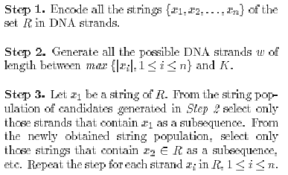
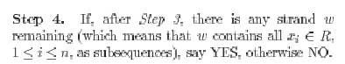

- Example:
=5
Rule: B->AC
D->TA
Encoding: ACTAAC
TAACTA
ACTATA

In the solution pool, we may find a string : TGATTGATAT,
such that

TGATTGATAT
ACTAAC
TAACTA
ACTATA
The complement of the common superstring : TGATTGATAT
We can find the nucleotide sequence of the common superstring by PCR. =>TGATTGATAT
ACTAACTATA
Decode the nucleotide sequence =>BDBDD

Created by: Hung-Wei Huang
Date: Sept. 17, 2003

